## DevOps MCQ

1. What does WSL stand for in the context of Windows?

**Answer: c. Windows Subsystem for Linux**

Rationale: WSL, denoting Windows Subsystem for Linux, serves as a compatibility layer within Windows, enabling the native execution of Linux applications.

2. What is the primary objective of continuous integration (CI) in DevOps?

**Answer: b. Regularly incorporating code changes**

Rationale: The principal aim of continuous integration (CI) is to consistently integrate code modifications into a shared repository, ensuring that contributions from various developers are frequently integrated and tested.

3. Within the Linux command line, what's the function of the cd command?

**Answer: b. Modifying the current working directory**

Rationale: The "cd" command, when utilized in the Linux command line, is employed to alter the present working directory, facilitating navigation within the file system.

4. Which of the options isn't categorized as a Linux distribution?

**Answer: c. Docker**

Rationale: Docker does not fall under the category of Linux distributions; instead, it stands as a platform designed for containerization and application deployment. Linux distributions comprise operating systems such as Ubuntu, CentOS, Debian, among others.

5. In the context of DevOps and containerization, what is Docker's primary use?

**Answer: c. Packaging and deploying applications in containers**

Rationale: Docker is predominantly employed for packaging applications and their dependencies into containers, streamlining the deployment, management, and scalability of applications within a consistent and isolated environment.

6. What is the primary function of Azure DevOps?

**Answer: b. Facilitating software development and delivery**

Rationale: Azure DevOps, provided by Microsoft, encompasses a suite of DevOps tools and services, primarily oriented toward supporting the complete software development life cycle, which includes planning, coding, building, testing, and delivery.

7. Which components are integral to Azure DevOps?

**Answer: c. Azure Boards and Azure Pipelines**

Rationale: Azure DevOps comprises multiple components, with Azure Boards for work item tracking and Azure Pipelines for continuous integration and continuous delivery (CI/CD) being two pivotal elements.

8. How does Azure DevOps contribute to version control in software development?

**Answer: b. Monitoring changes in source code and overseeing version management.**

Rationale: Azure DevOps provides version control tools, such as Azure Repos, which are instrumental in tracking source code changes, managing version history, and promoting collaborative development among team members.

9. What is the primary role of the root user in Linux?

**Answer: c. Carrying out administrative tasks with superuser privileges**

Rationale: The root user in Linux is vested with superuser privileges and is entrusted with responsibilities pertaining to administrative tasks, system management, and system-wide alterations.

10. In the realm of Azure DevOps, which component is utilized for defining, constructing, testing, and deploying applications?

**Answer: c. Azure Pipelines**

Rationale: In the context of Azure DevOps, Azure Pipelines takes on a central role, being employed to define, construct, test, and deploy applications within a continuous integration and continuous delivery (CI/CD) pipeline, rendering it an indispensable component for software development and deployment in Azure DevOps.

## DevOps Labs

Lab 1: File and Directory Management

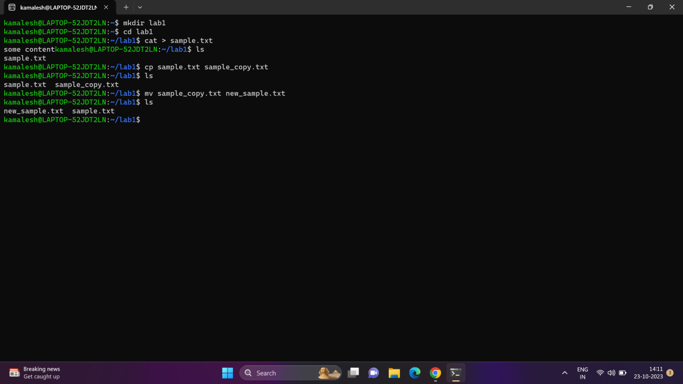

Lab 2: Permissions and Ownership

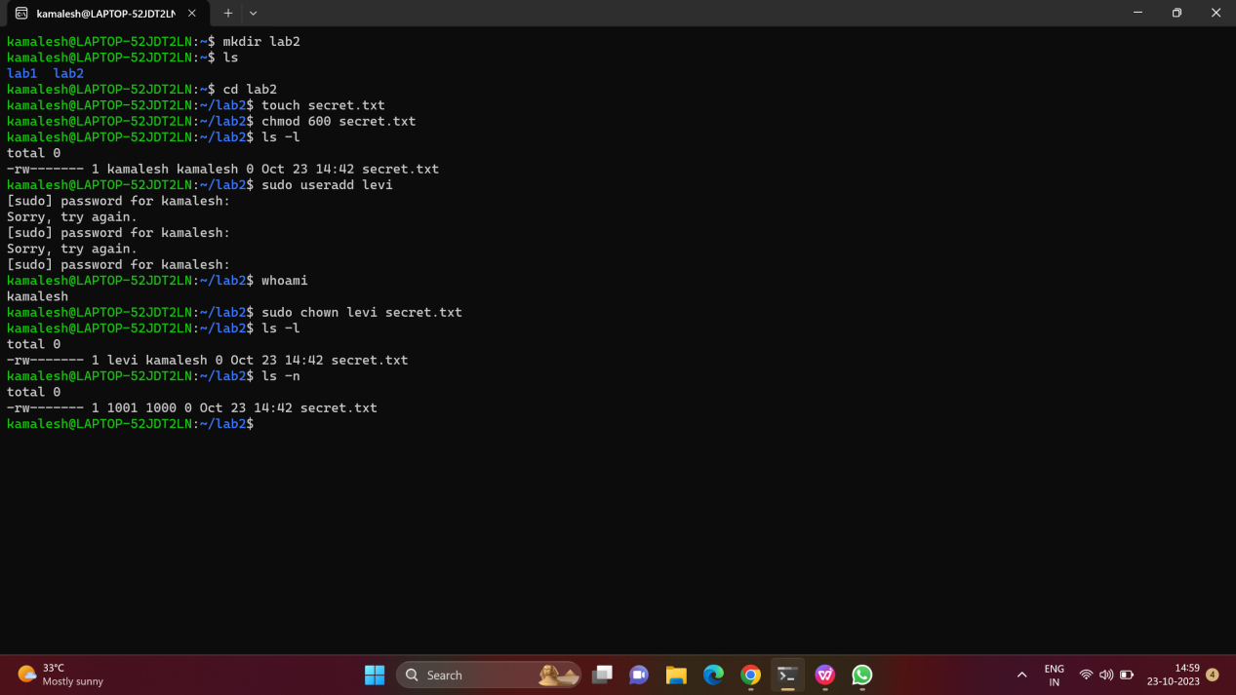

Lab 3: Text Processing with Command Line Tools

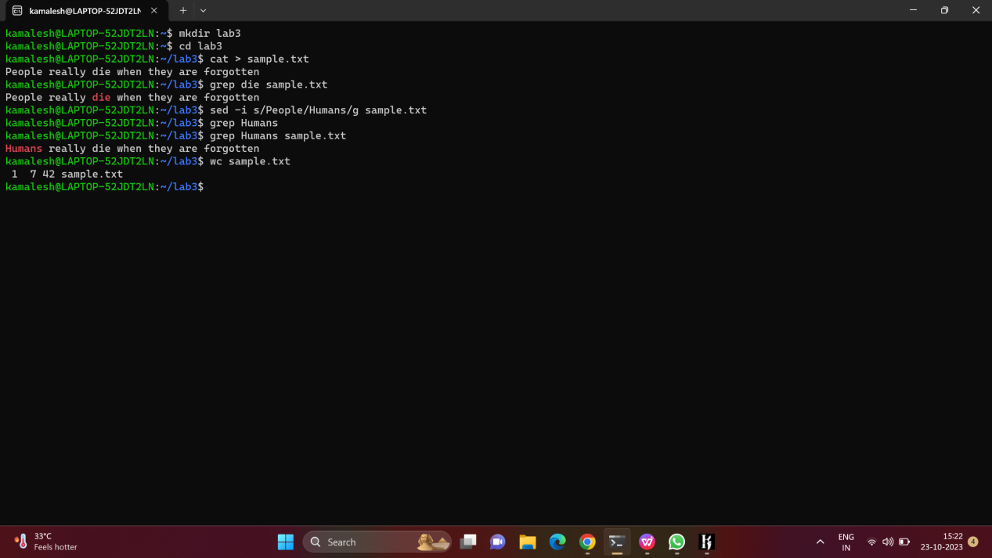

Lab 4: Creating a Simple YAML File

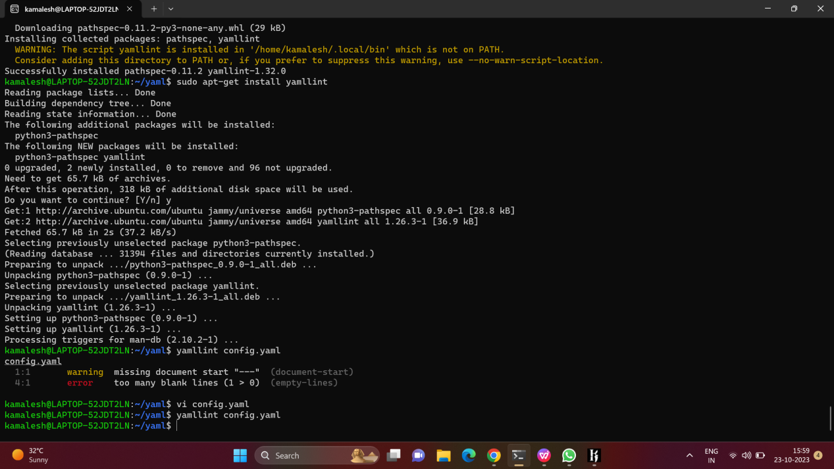

Lab 5: Working with Lists in YAML

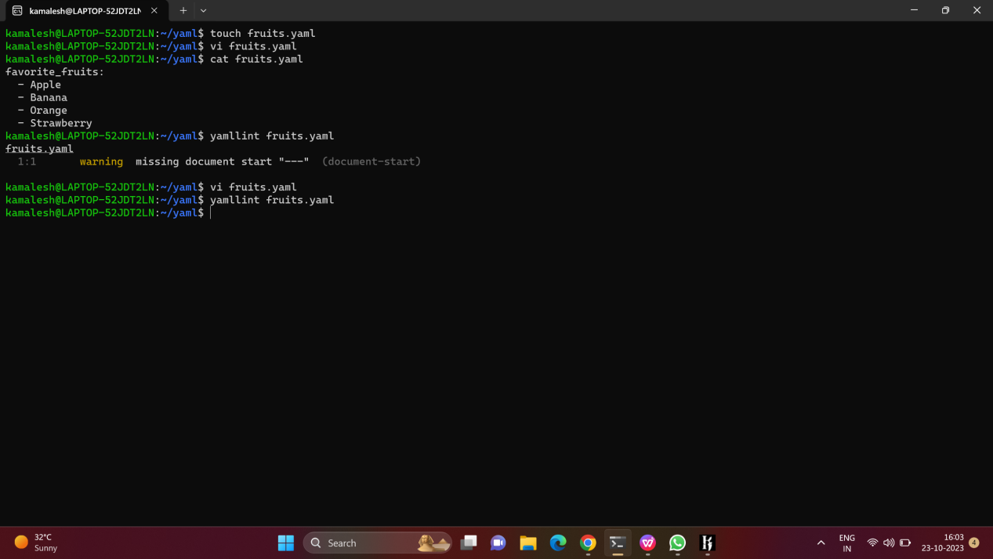

Lab 6: Nested Structures in YAML

1)Creating nested list

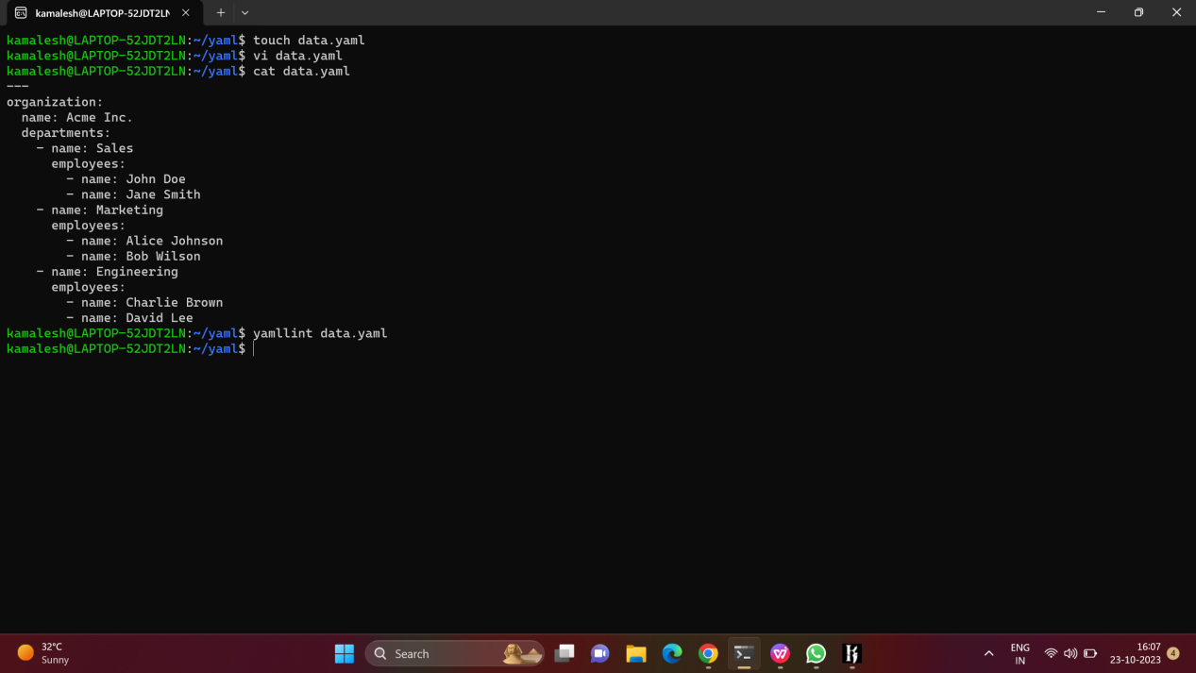

1. Adding new contents

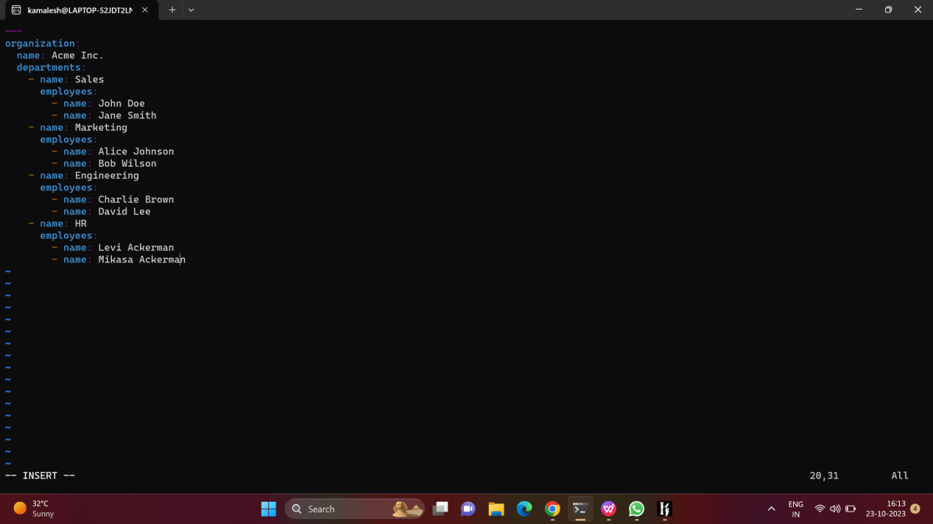

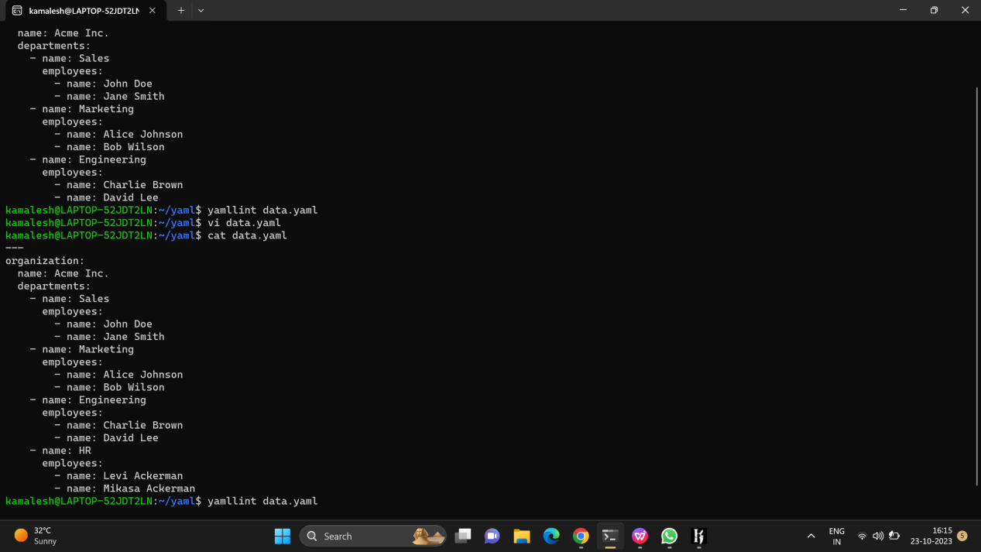

1. Removing some contents

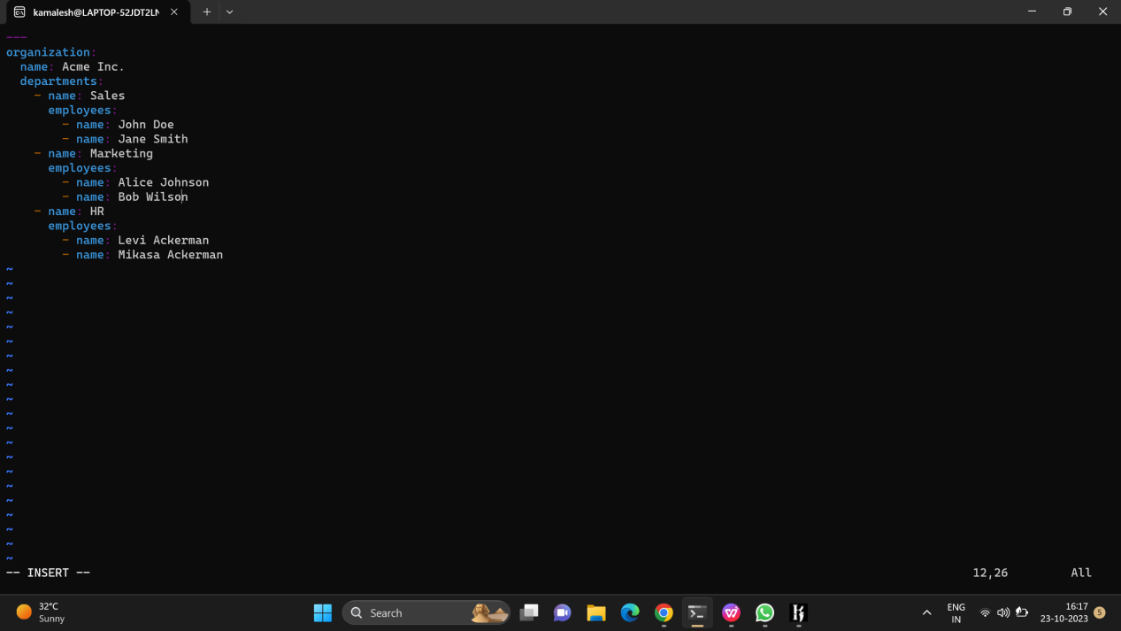

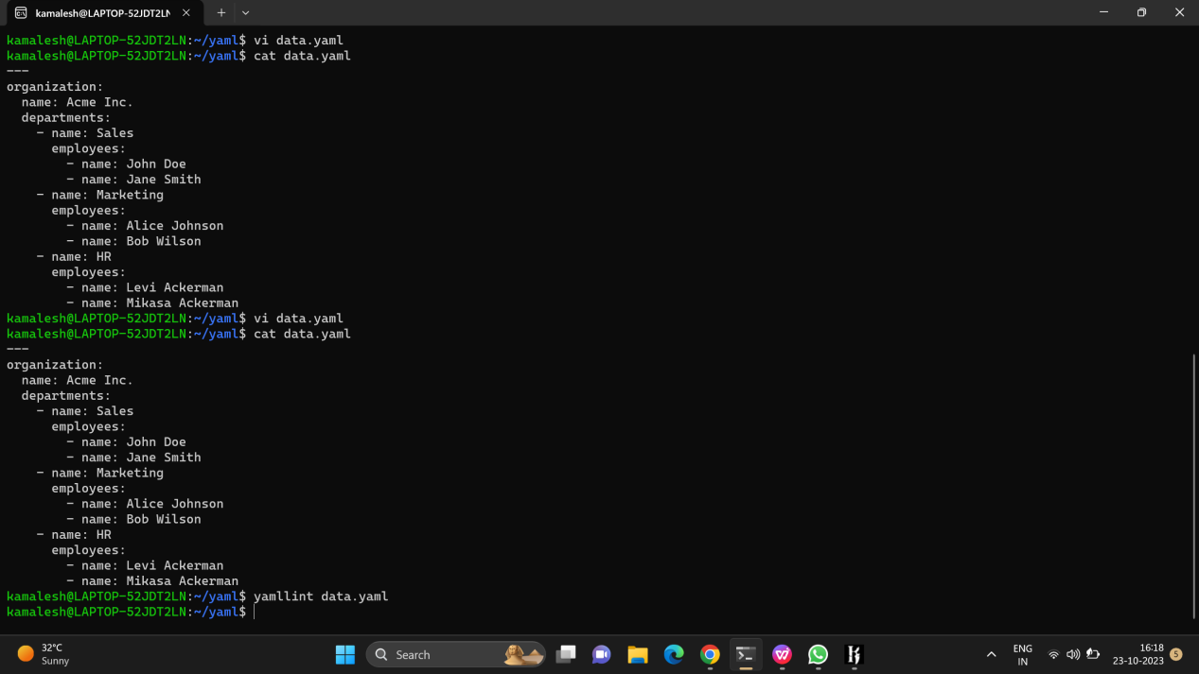

Lab 7: Create Classic Azure CI Pipeline for Angular Application

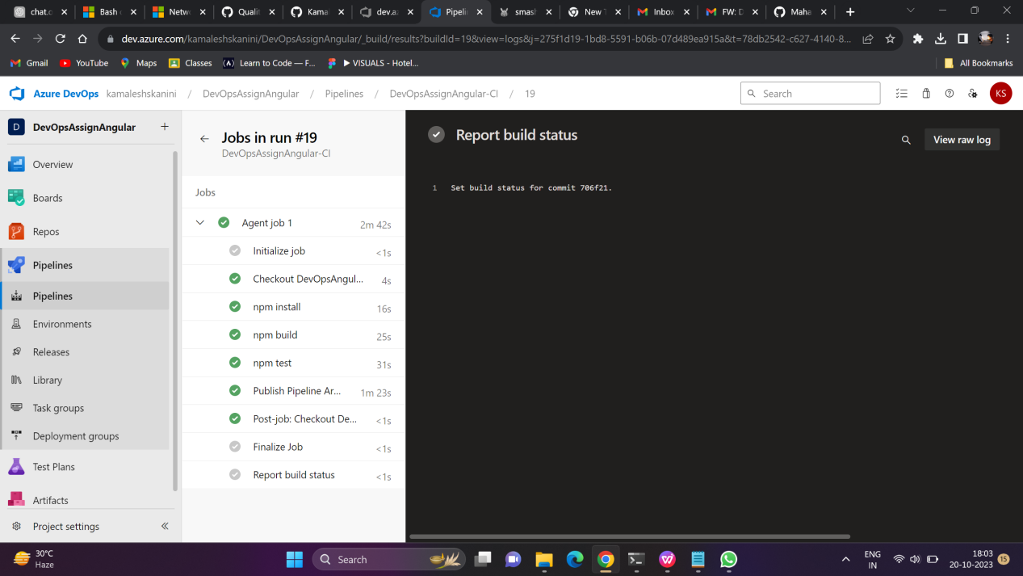

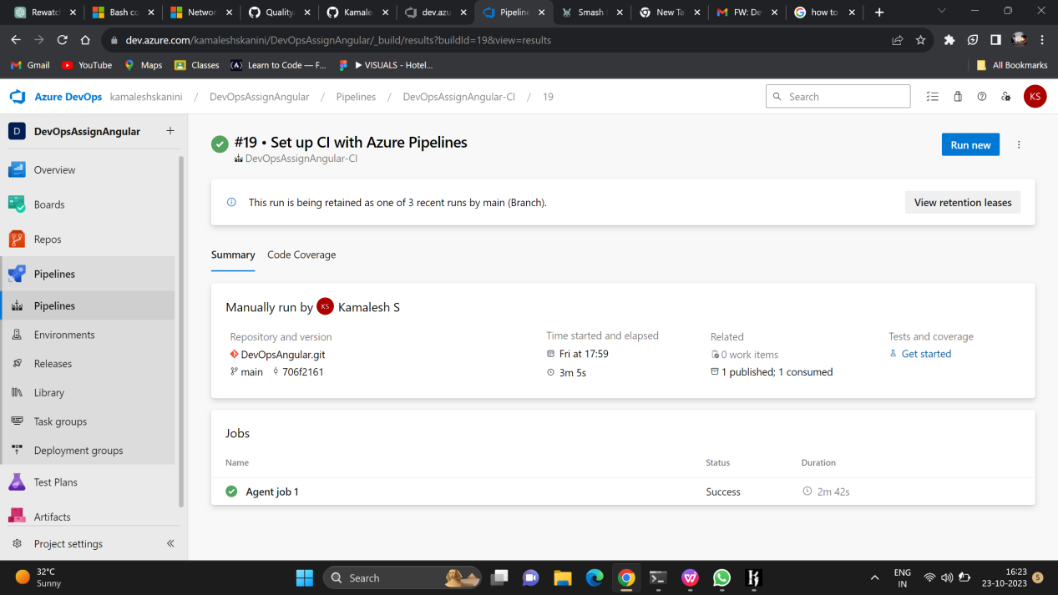

Lab 8: Create YAML Azure CI Pipeline for React Application

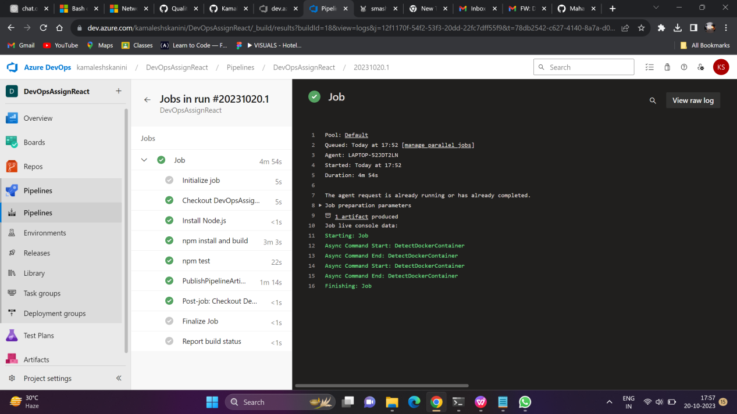

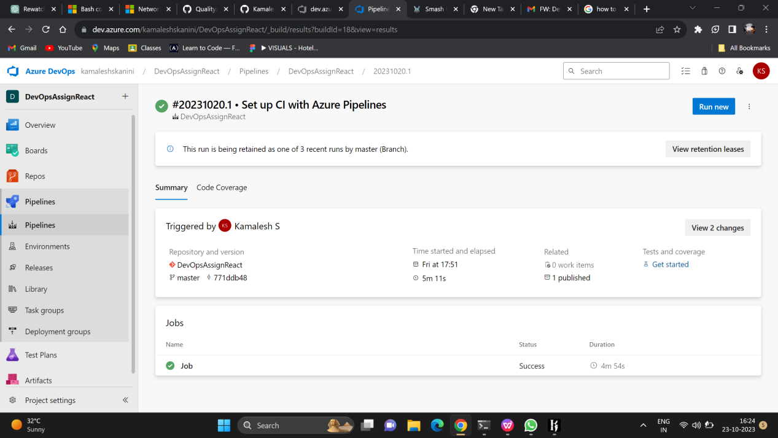

Lab 9: Create CI Pipeline for .NET Core Application with MS Unit Test

